NAME: …………………………………………………………….……. DATE: …………………
CLASS: …………………………………………………………….……. MARK: ______/80

(Time: 45 minutes)

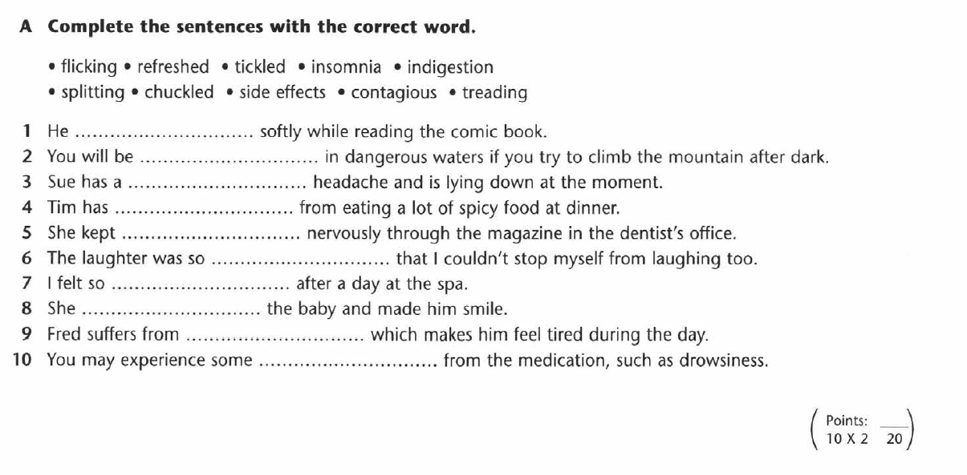

B. Rewrite the sentences using the passive.

1 Industrial waste is polluting lakes and rivers.
2 Hunters have hunted the elephant almost to extinction.
3 Global warming is heating up the planet.
4 Illegal loggers have cut down hundreds of trees.
5 WWF protects threatened habitats around the world.
Points: ____
5×420

Reading
C. You are going to read an article about a type of diet. Read the text and choose the correct parts of sentences (A-G) to complete gaps 1-6. There is one extra part of a sentence you do not need to use. Write your answers in the table.

During recent years, people have become obsessed with their weight. The desire of people to look like their favourite movie star or supermodel has prompted an almost endless list of celebrity-endorsed diets. Actress Jodie Foster says ‘Yes!’ to the Beverly Hills Diet, Kylie Minogue uses the Montignac Diet and Sarah-Michelle Gellar even gives a thumbs up to a Cabbage Soup Diet! But no nutritional programme has gained quite so much attention as the world-famous Atkins Diet.
Brad Pitt, Jennifer Aniston and Catherine Zeta-Jones are just a few of the personalities 1) ……… . So what is ‘Atkins’, why does it have such a high-profile following and, more importantly, is it safe?
The basic idea of the diet is quite simple. Atkins dieticians claim that carbohydrates are the reason 2) ……… . These included foodstuffs such as flour and sugar, like you would find in a cake. Our bodies burn carbohydrates first. So the Atkins scientists say that if we cut down on these carbohydrates, our bodies will search for other forms of energy to burn instead. When our bodies burn fat, we naturally become less hungry, 3) ……… .
Not everybody thinks 4) ……… . Several nutritionists have said that the diet upsets the balance of fruit and vegetable intake 5) ……… . The human body needs a variety of minerals and vitamins and these should be part of any diet. It is also thought that the Atkins diet is too low in fibre, which is mainly found in bread, cereals and potatoes. There is wide scientific agreement that lack of fibre can cause serious stomach problems. However, an Atkins spokesman has rejected claims made about flaws in the diet. He agrees that the intake of fruit and vegetables is reduced at the beginning of the diet, 6) ……… . Dieters also are encouraged not to neglect fibre and the Atkins website advertises a special range of bread and cereals which ensure that a person’s nutritional needs are met.
A number of scientific studies back the claim that Atkins is a good way to lose weight quickly as noticeable results can easily be seen after a short length of time. Life in the limelight is very likely the reason that celebrities choose to use this diet, but if you are considering trying it, you should consult a doctor first. Atkins is only successful if it is well-planned, nutritious and includes regular exercise.
A which includes other forms of energy
B who have tried the diet
C that Atkins is the best way to lose weight, though
D why we put on weight
E which they think is necessary for us to stay healthy
F so we start to lose weight
G but there is still a healthy amount that is slowly increased

1 | 2 | 3 | 4 | 5 | 6

Points: ____
6×530

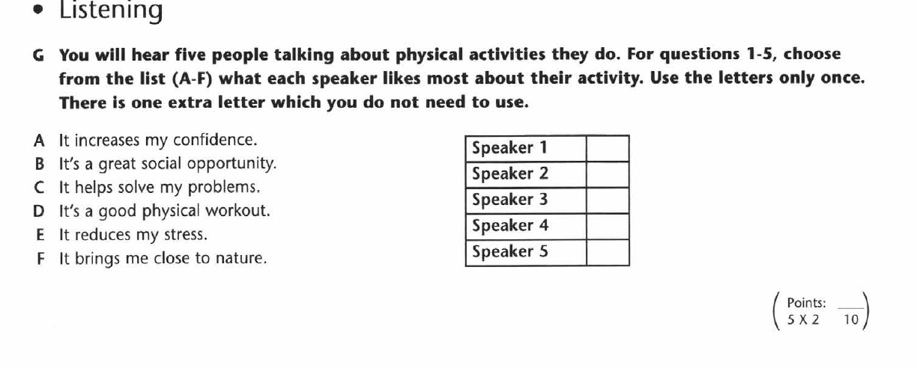
D.

Keys.

А.
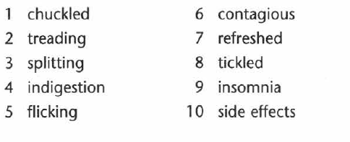

B. 1 Lakes and rivers are being polluted with/by industrial waste.
2 The elephant had been hunted almost to extinction by poachers.
3 The planet is being heated up by global warming.
4 Hundreds of trees have been cut down by illegal loggers.
5 Threatened habitats around the world are protected by WWF

C.
1 B 3 F 5 E
2 D 4 C 6 G

D. 1D 3F 5A
2B 4C
